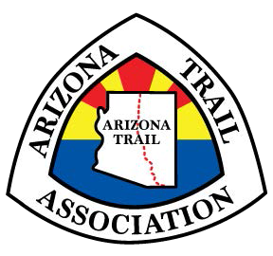

Board of Directors – 2022

Susan Lagerman
President
2252 E. State Avenue
Phoenix, AZ 85020 sblagerman@gmail.com
(602) 620-5353 (c)
(602) 997-0479 (h)
Retired Assistant Arizona Attorney General

Lisa Schnebly Heidinger
Secretary
1236 E. Villa Maria Drive
Phoenix, AZ 85022
lisa@arizonawriter.com
(602) 788-6558
Journalist and fourth generation Arizonan

Ambika Balasubramaniyan
Treasurer
2850 E. Capricorn Place Chandler, AZ 85249 abalasub@hotmail.com
(602) 750-0052
Intel (Data Analytics) and Arizona Highways Photo Workshops (Event Organizer and Photographer)

James Arndt
3519 E. Piccadilly Rd
Phoenix, AZ 85018
(480) 225-7360 (c)
jarndt@phoenixunion.org
Assistant Principal, Pueblo del Sol Elementary School

Kait Boyle
45 Arrow Root Ln
Victor, ID 83455
kait.boyle@gmail.com
(978) 808-9916 (c)
World champion mountain bike endurance athlete

Dana Ernst
VP Trail Operations
1244 E. Olivine Way
Flagstaff, AZ 86001
(303) 818-6459 (c)
ernst.tribe@gmail.com
Mathematics professor, Northern Arizona University

Victoria Levin
VP Membership Development
4625 W. Chicago Street
Chandler, AZ 85226
(520) 256-1793
valevin1188@gmail.com
Federal attorney

Phyllis Ralley
308 W. Siesta Way
Phoenix, AZ 85041
arcosanti75@gmail.com
(602) 740-5304 (c)
Bureau of Land Management Public Information Officer

Bianca Salazar
2795 North Fox Run Drive
Flagstaff, AZ 86004
(928) 853-1734 (c)
biancaholderman@gmail.com
Thru-hiker and property management professional

